## Overview:

We’ll be starting the hands-on portion of the AWS Introduction module by building a security group and a server in the us-west-2 region of AWS.

## Create your Test Instance Security Group:

The procedure will below will create a Security Group that will be used to allow port 22 (ssh) ingress to your newly created “Test” EC2 instance.

1. Go to the AWS EC2 Console and select “Security Groups” from the left-hand navigation bar.
2. Click “Create Security Group”  
   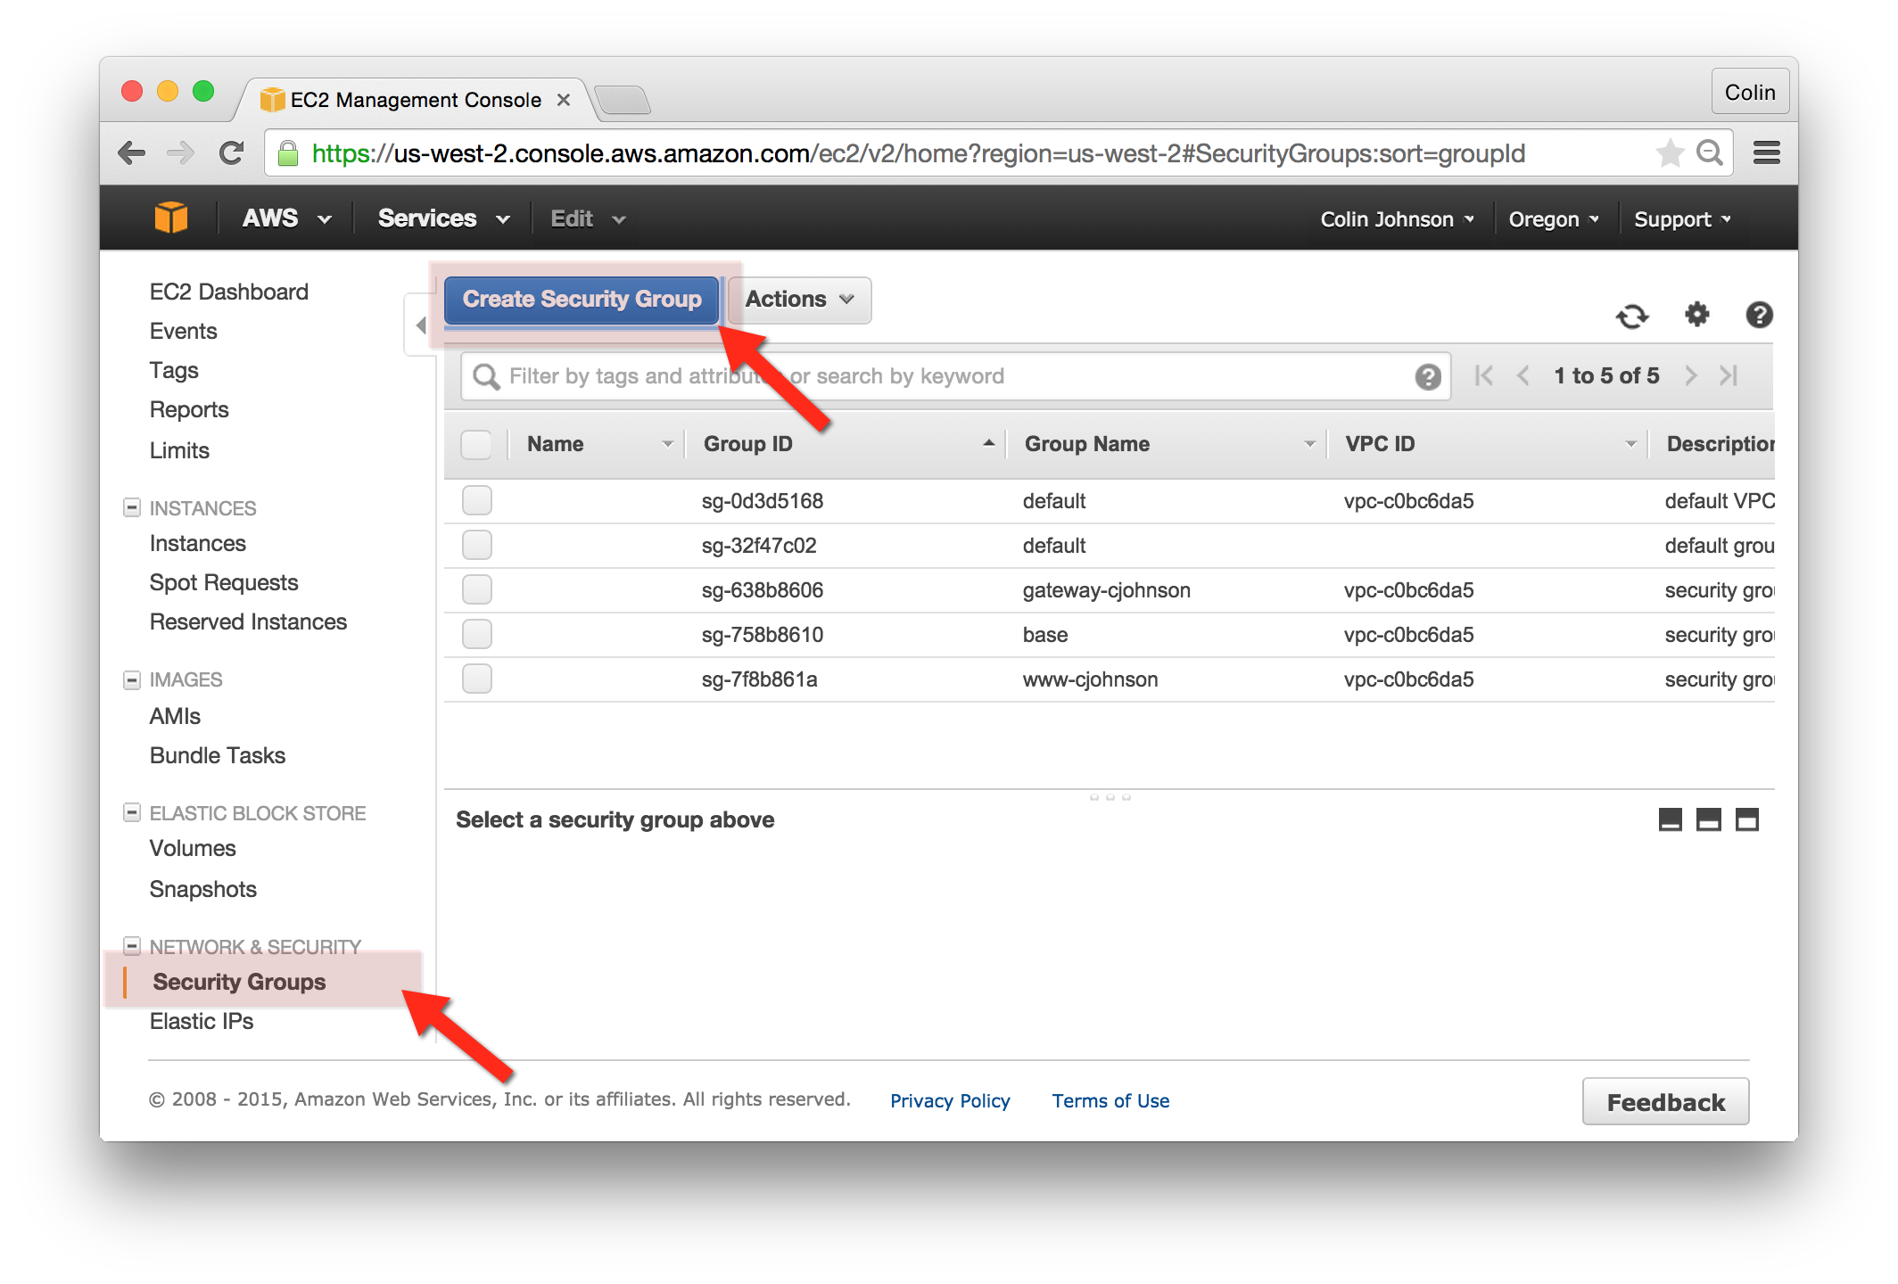
3. In the “Create Security Group” window, enter the following values:
   1. Security group name: test-yourname
   2. Description: security group for test-yourname Instance
   3. VPC: chose the “default VPC” – this VPC will be denoted by an asterisk at the end of the VPC name
   4. Security group rules:
      1. Inbound
         1. Type: SSH
         2. Protocol: TCP
         3. Port Range: 22
         4. Source: Anywhere / 0.0.0.0/0
         5. Press “Create”  
            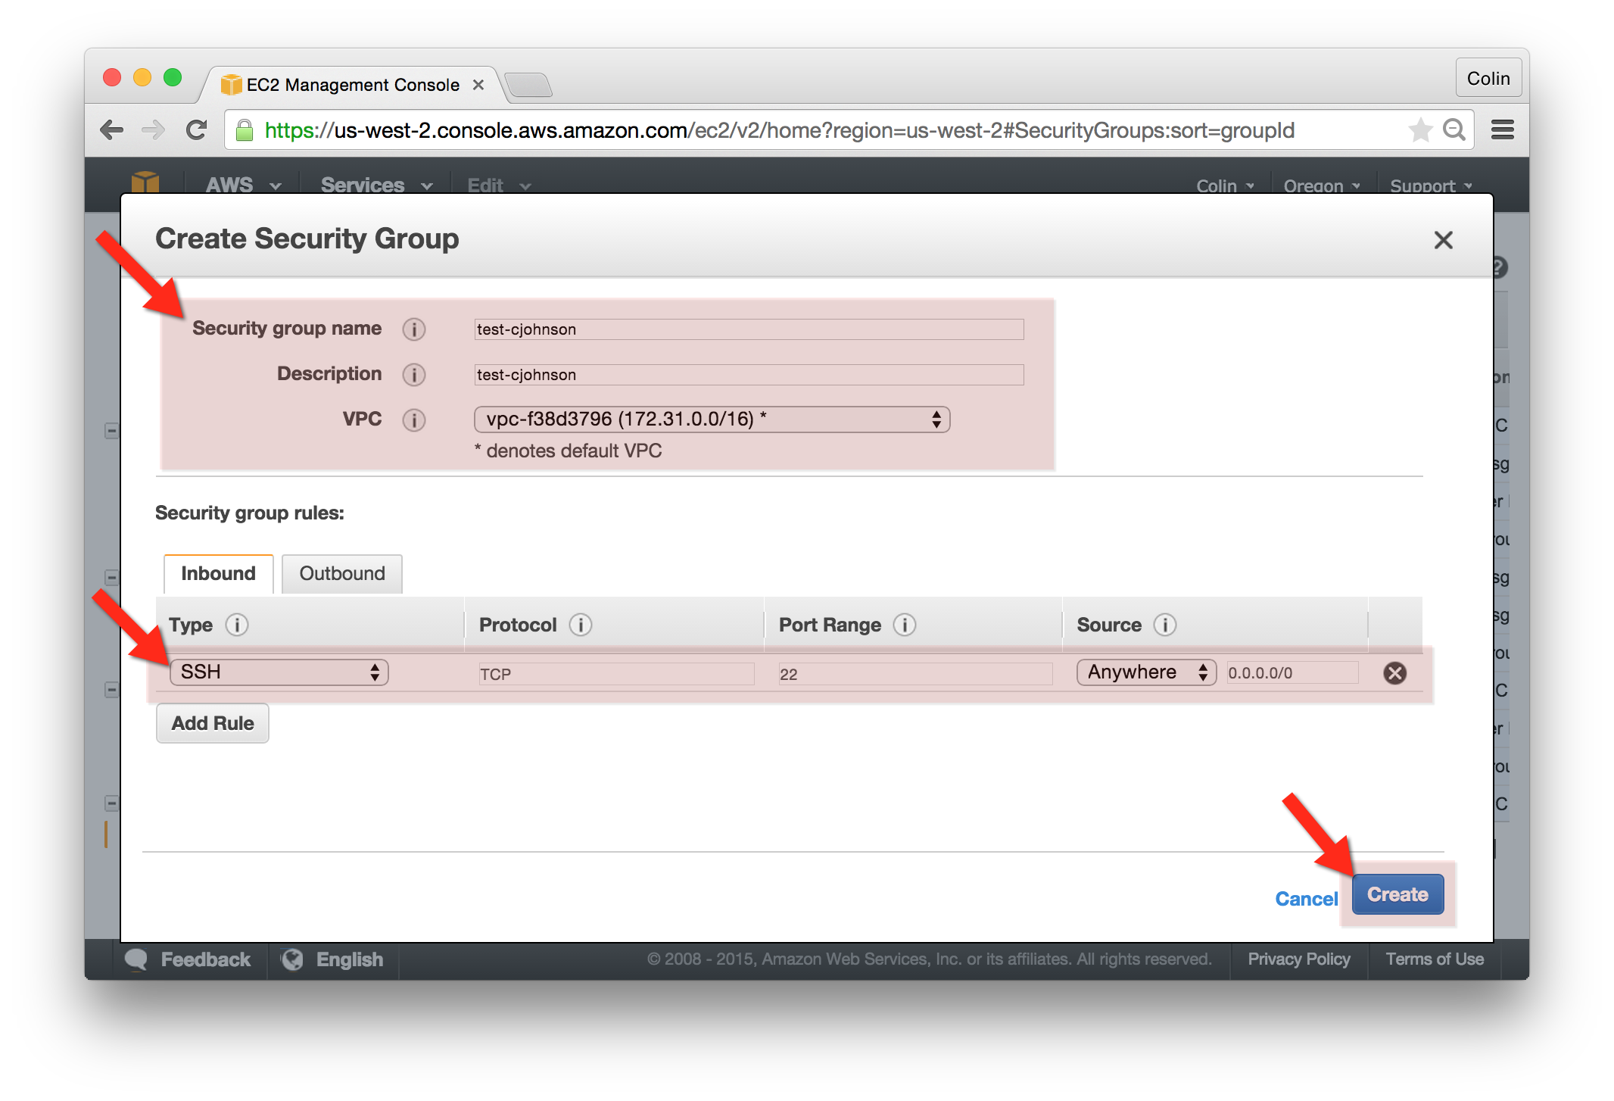

## Create your Test Instance:

The procedure will below will create your “Test” EC2 instance.

1. Go to the AWS EC2 Console and select “Instances” from the left-hand navigation bar.
2. Select “Launch Instance”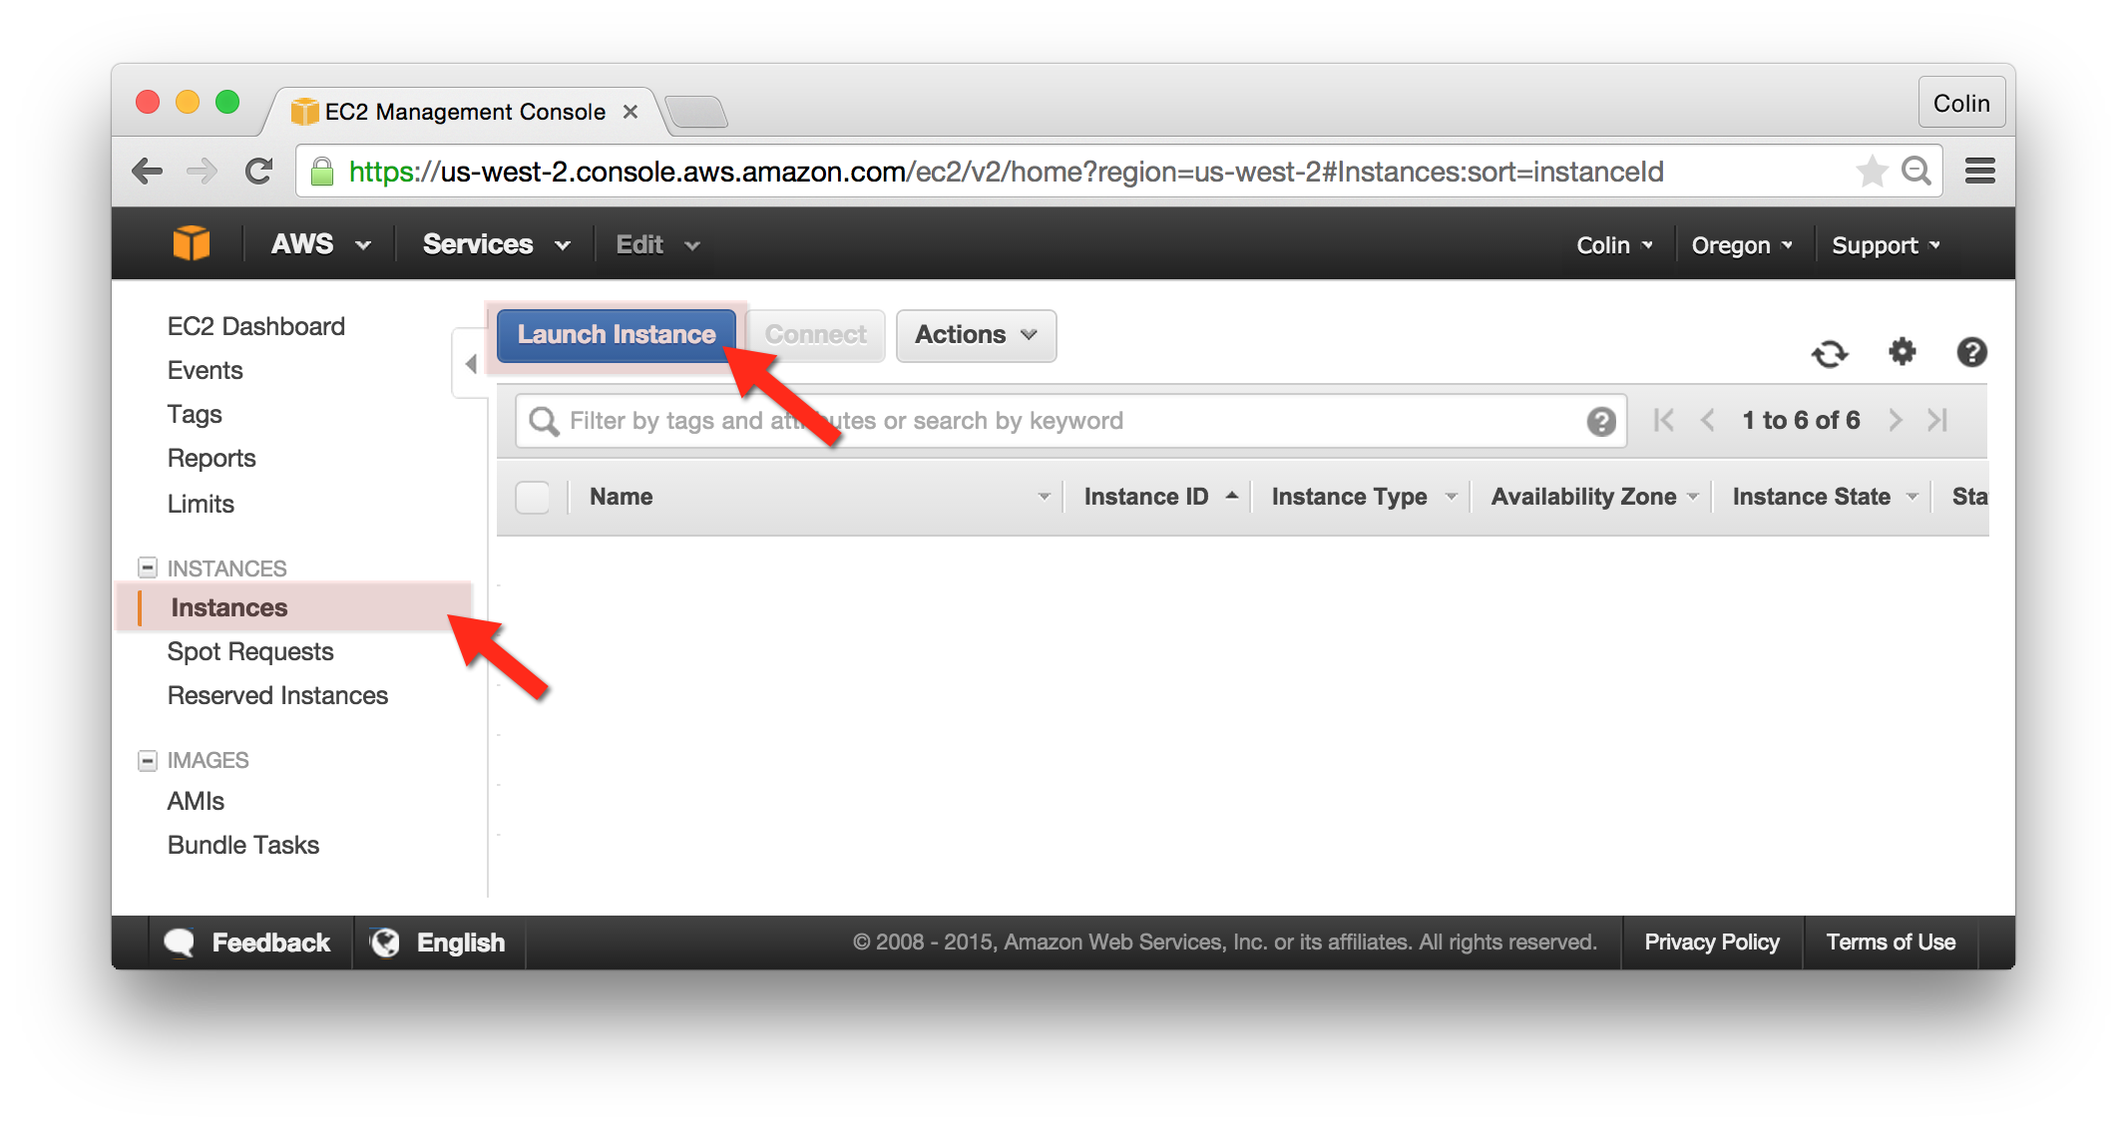
3. Choose AMI:
   1. Choose the Ubuntu Server 14.04 LTS (HVM), SSD Volume Type AMI (ami-5189a661)
   2. Press “Select”  
      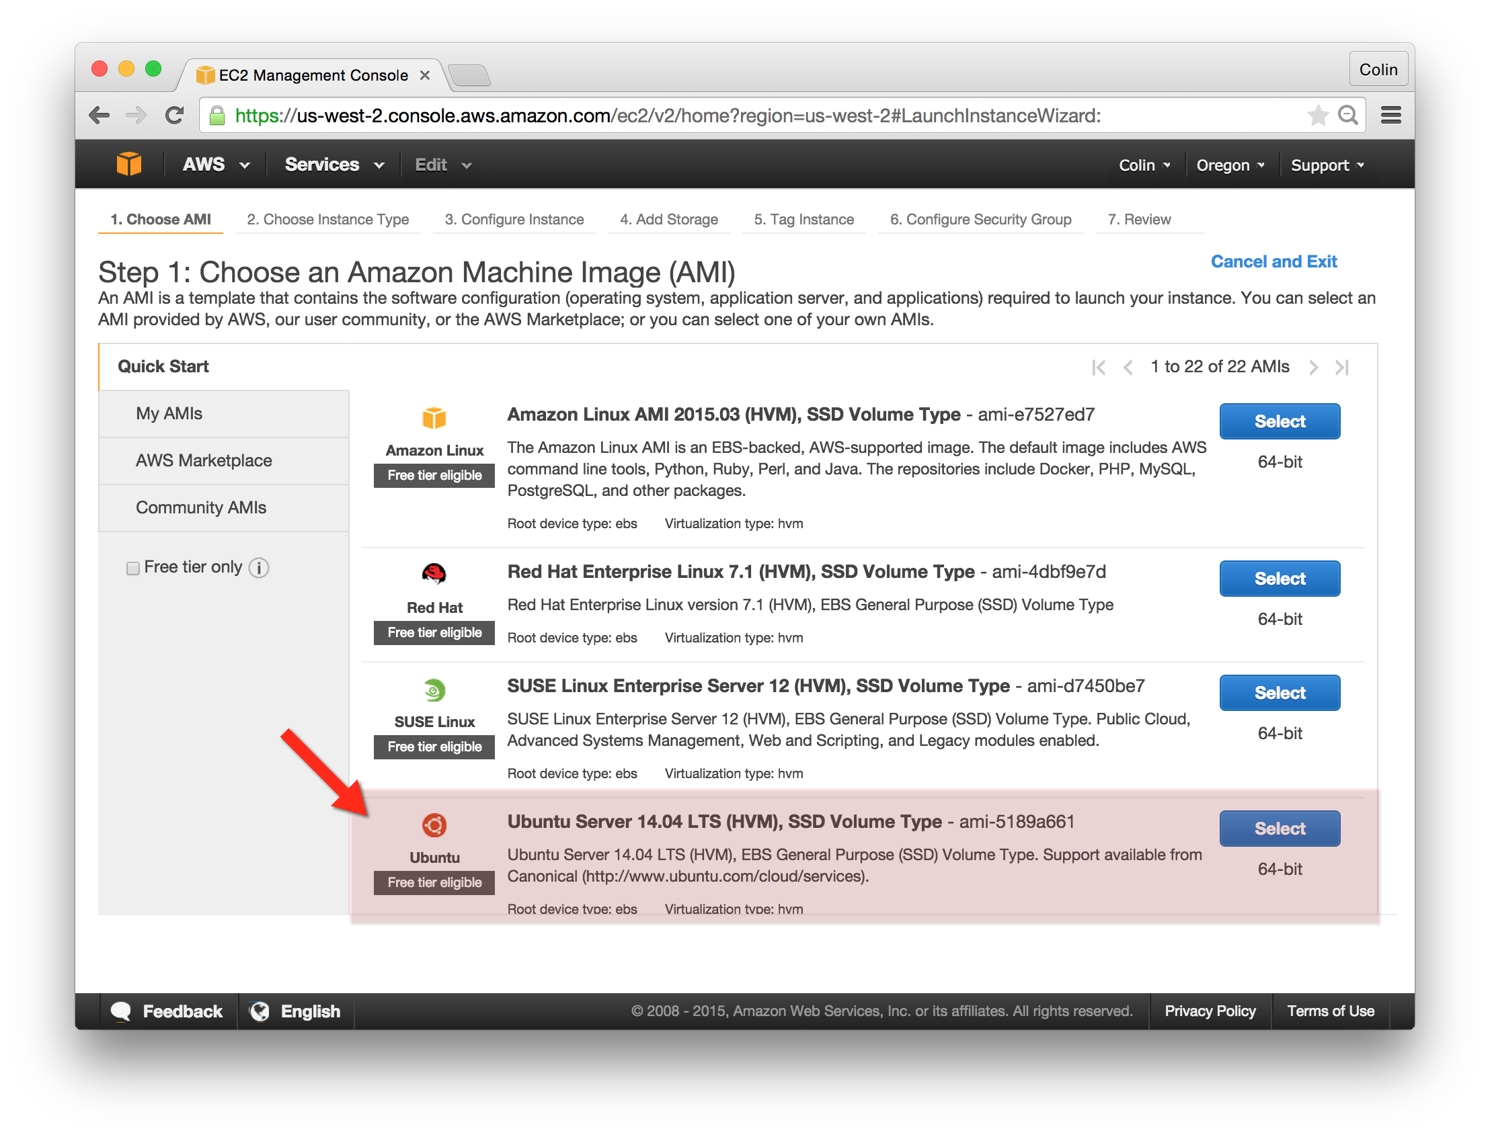
4. Choose Instance Type:
   1. Instance Type: t2.micro
   2. Press “Next: Configure Instance Details”  
      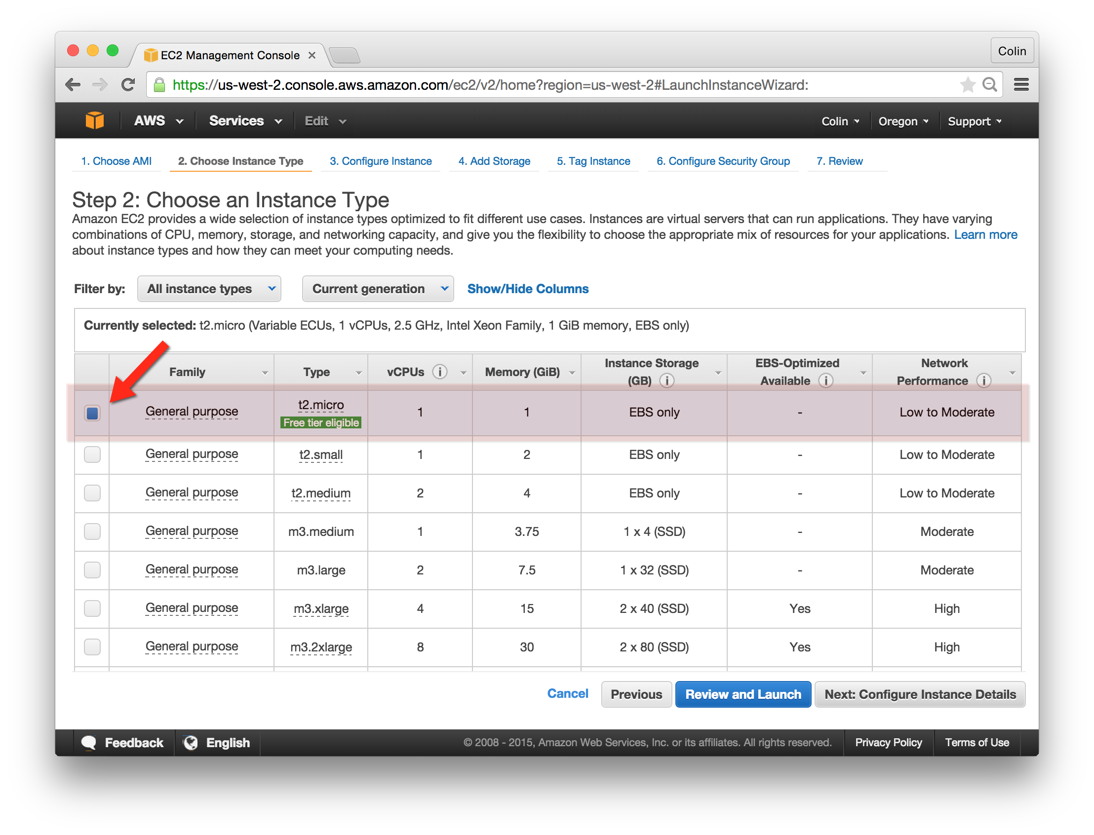
5. Configure Instance Details:
   1. Number of instances: 1
   2. Network: vpc-f38d3796 (“Default” VPC)
   3. Subnet: No preference
   4. Auto-assign Public IP: Enable
   5. IAM role: None
   6. Click “Next: Add Storage”
6. Add Storage
   1. Click “Next: Tag Instance”
7. Tag Instance:
   1. Key=Name, Value=test-cjohnson  
      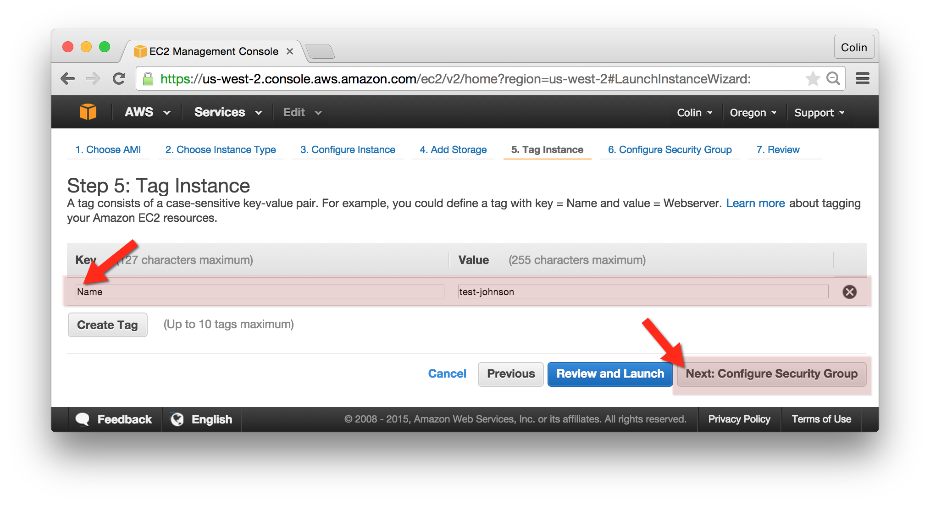
8. Configure Security Group:
   1. Choose the “test-yourname” security group created previously. *This will allow port 22 in on a your newly created “Test” instance.*
   2. Click “Review and Launch”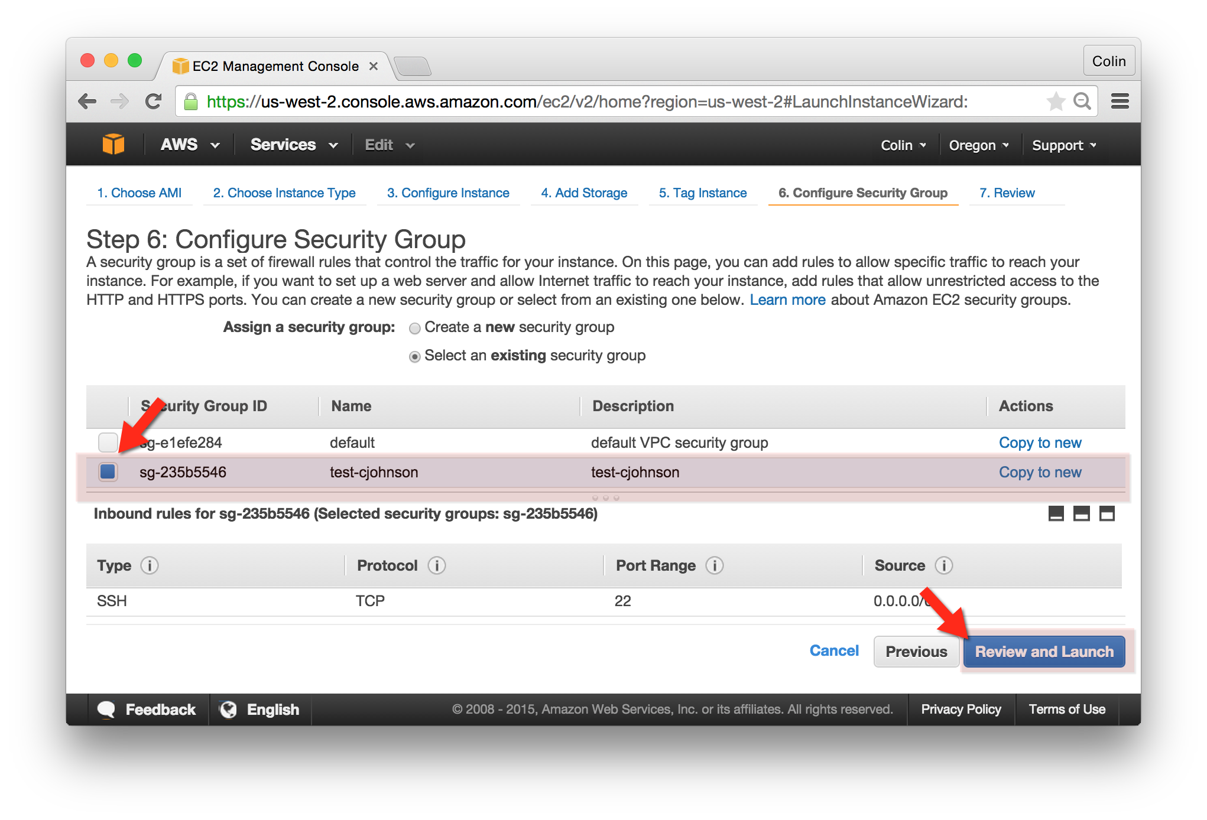
9. Review and Launch:
   1. Instance Type: t2.micro
   2. Security Group: test-yourname
   3. Instance Details:
      1. Network: vpc-f38d3796
      2. Assign Public IP: Enable
   4. Tags
      1. Name: test-yourname
   5. Click “Launch”  
      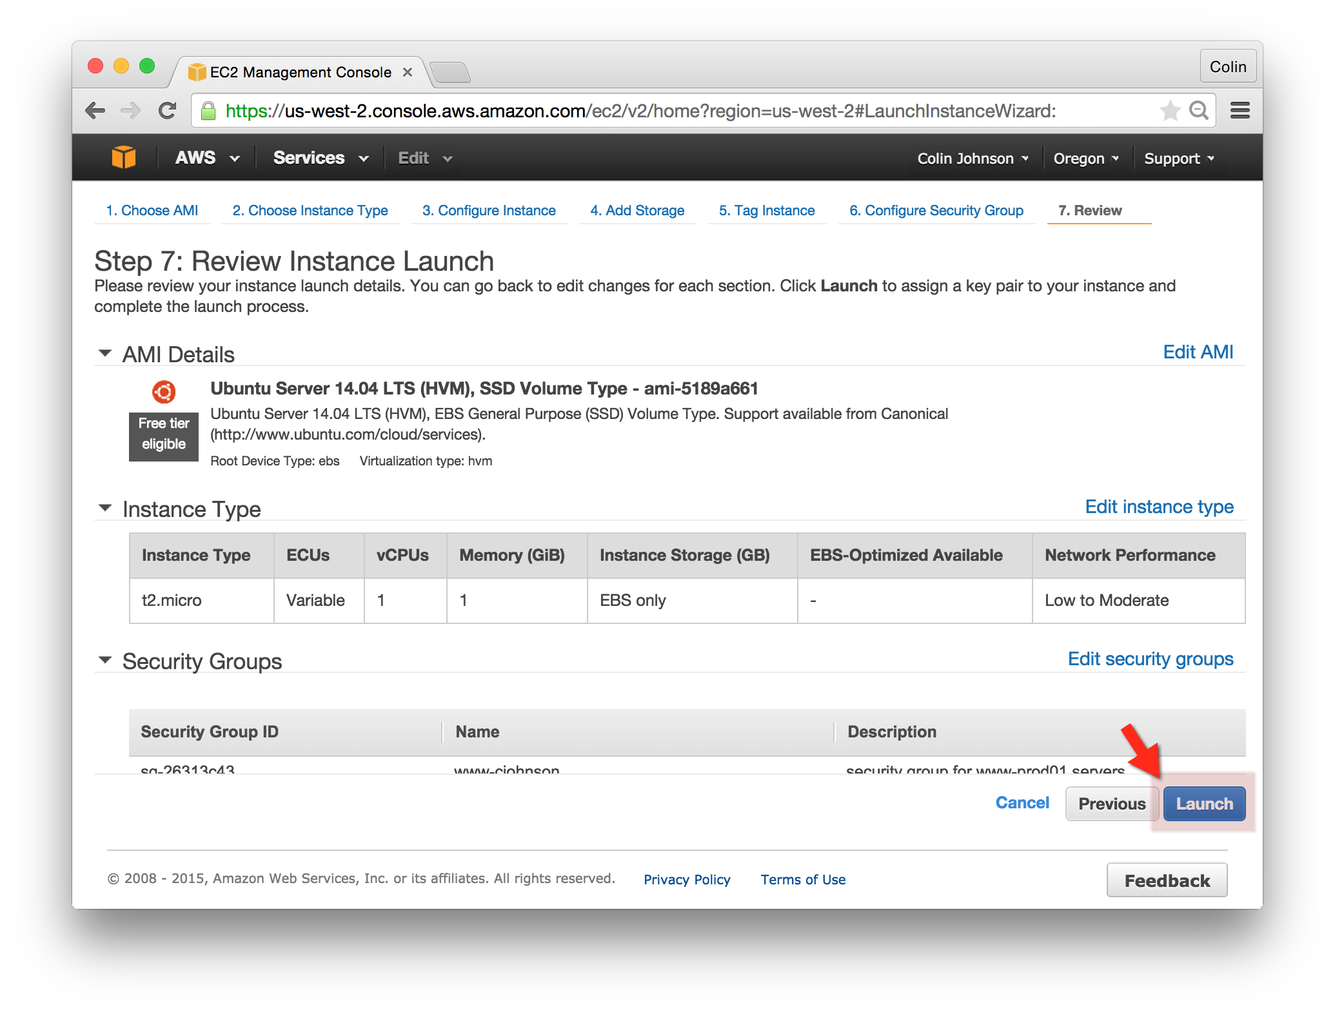
10. Keypair:
    1. Create a new key pair
    2. Key pair name: cjohnson
    3. “Click Download Keypair” – save this keypair for future labs!
    4. Click “Launch Instances”  
       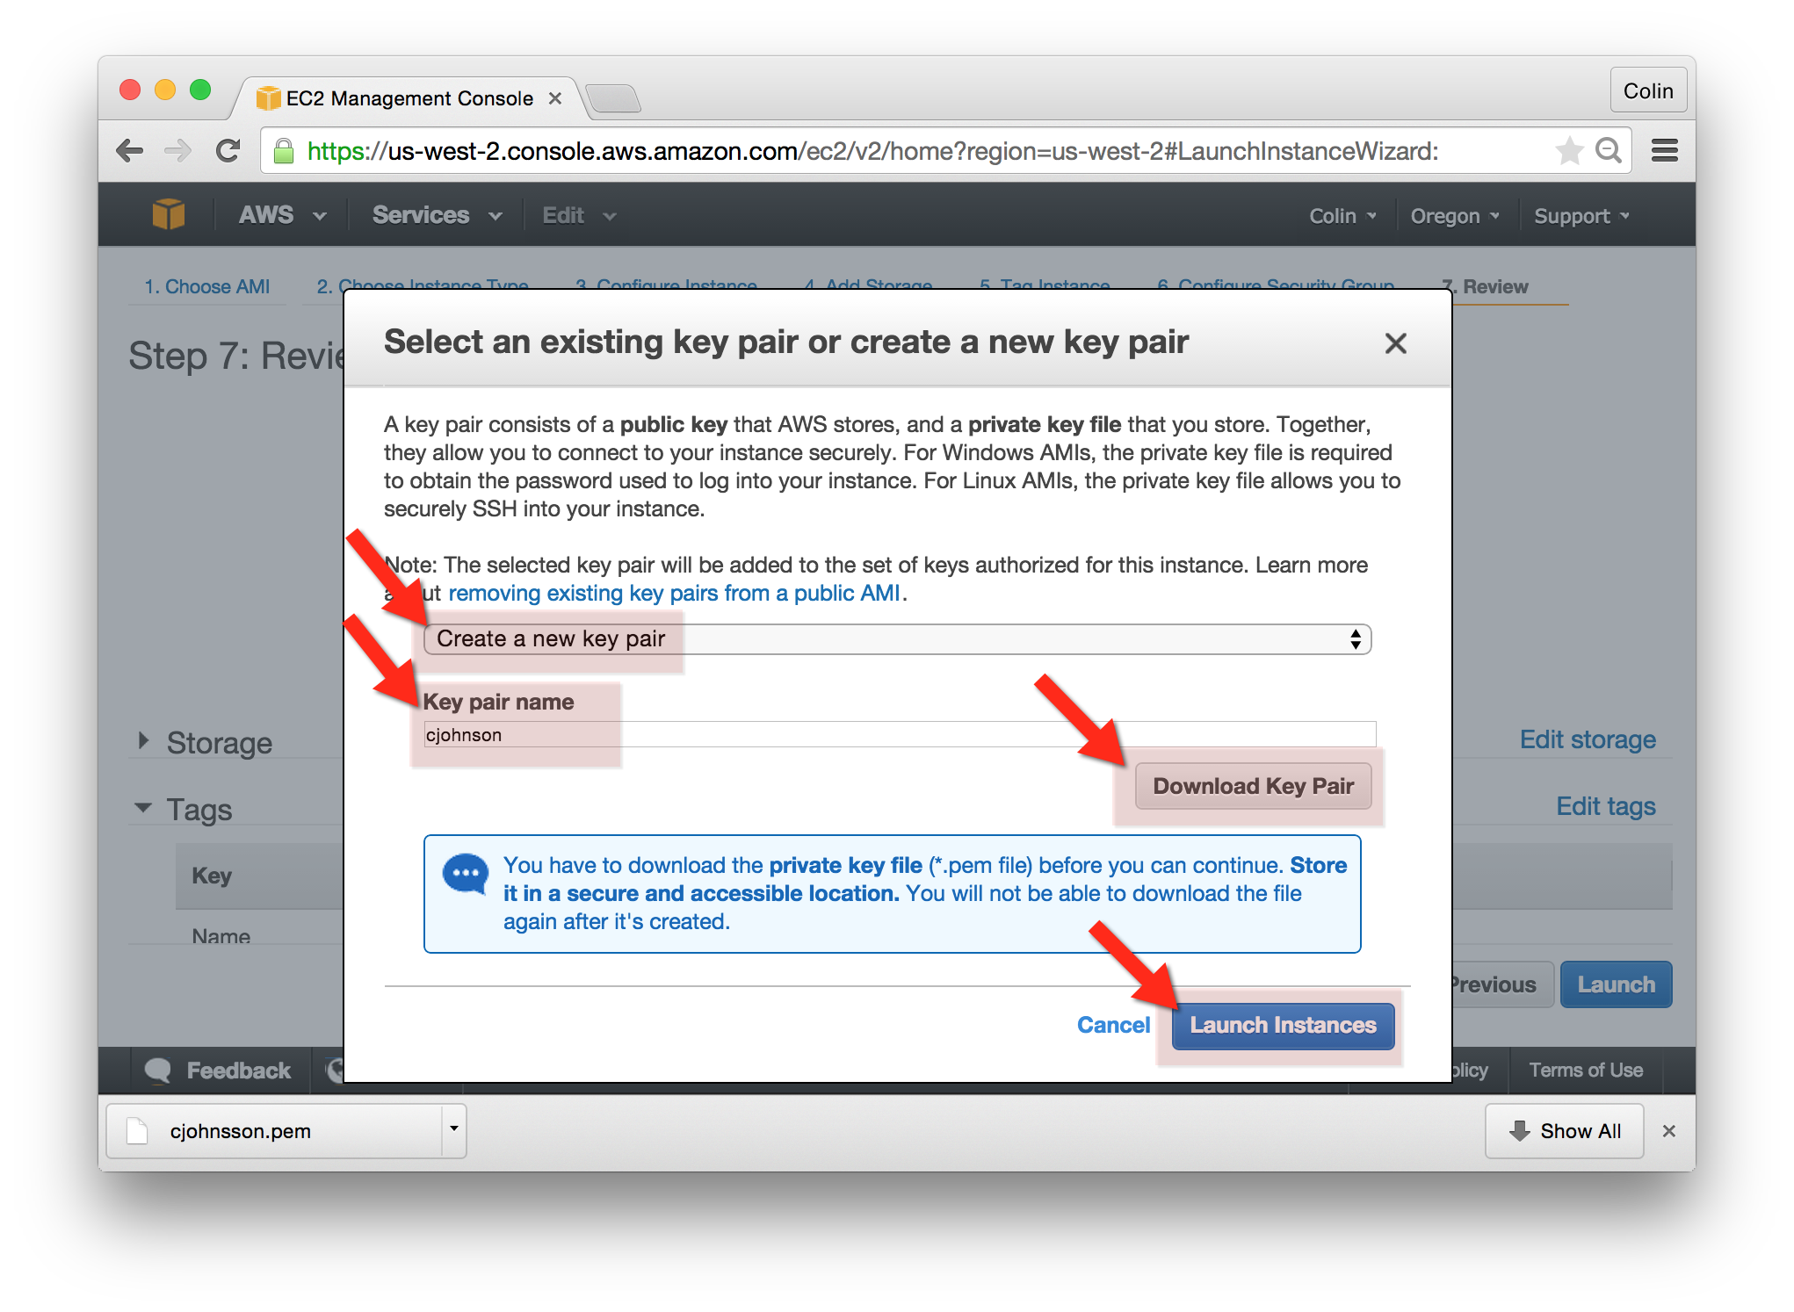

## Launch!

You’ll see a note that “Your instances are now launching.” You’ve created a Security Group and built an AWS EC2 Server! 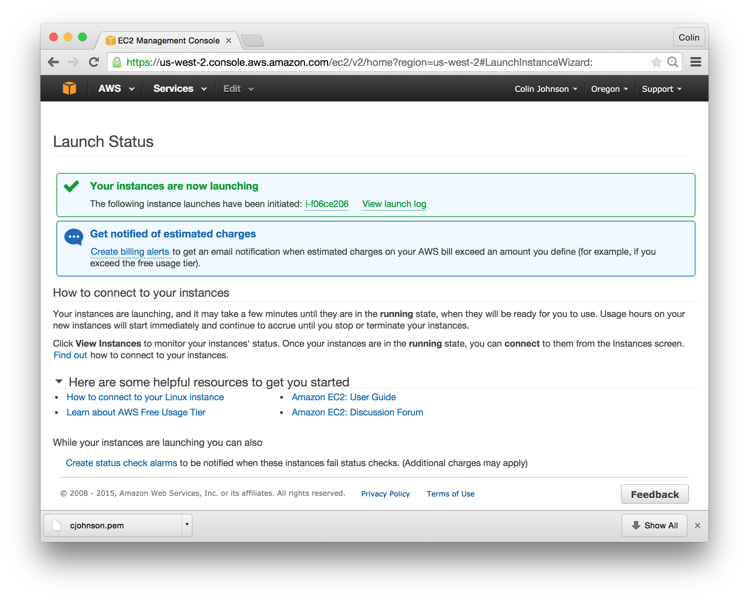

## Login!

You’ll want to ssh into your new instance. In order to do this, you’ll need the instance’s Public IP address and your Keypair.

1. Go to the AWS EC2 Console and select “Instances” from the left-hand navigation bar.
2. Use the “Filter” and filter by “test-yourname” to locate your instance.
3. In the Instance Description tab, locate the Public IP and copy it.  
   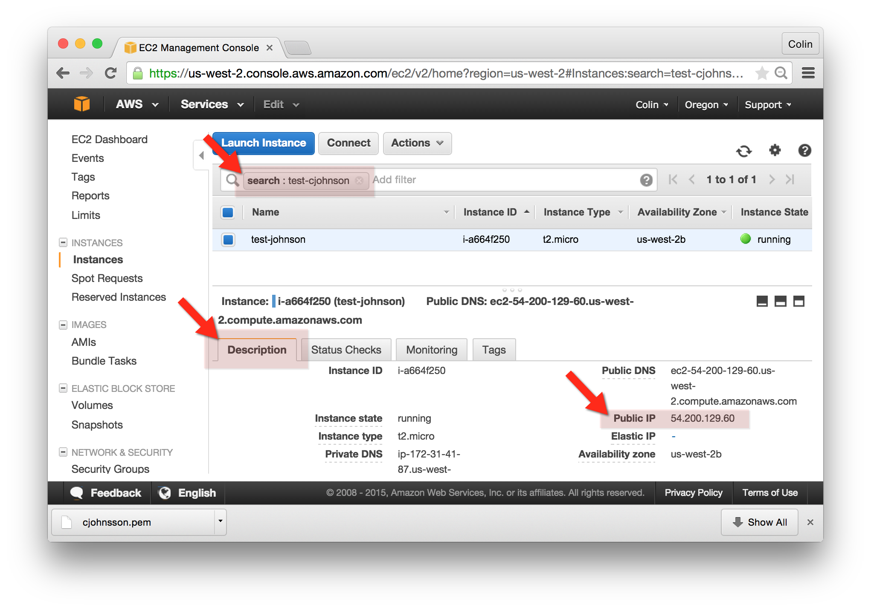
4. With this information, you should be able to login as follows:
   1. ssh -i ~/path/to/keyfile.pem [ubuntu@x.y.z.z](mailto:ubuntu@x.y.z.z)

## Delete!

After you’ve logged in, please delete both the instance and security group. The other labs will not need to make use of the “Test” instance that we just created.